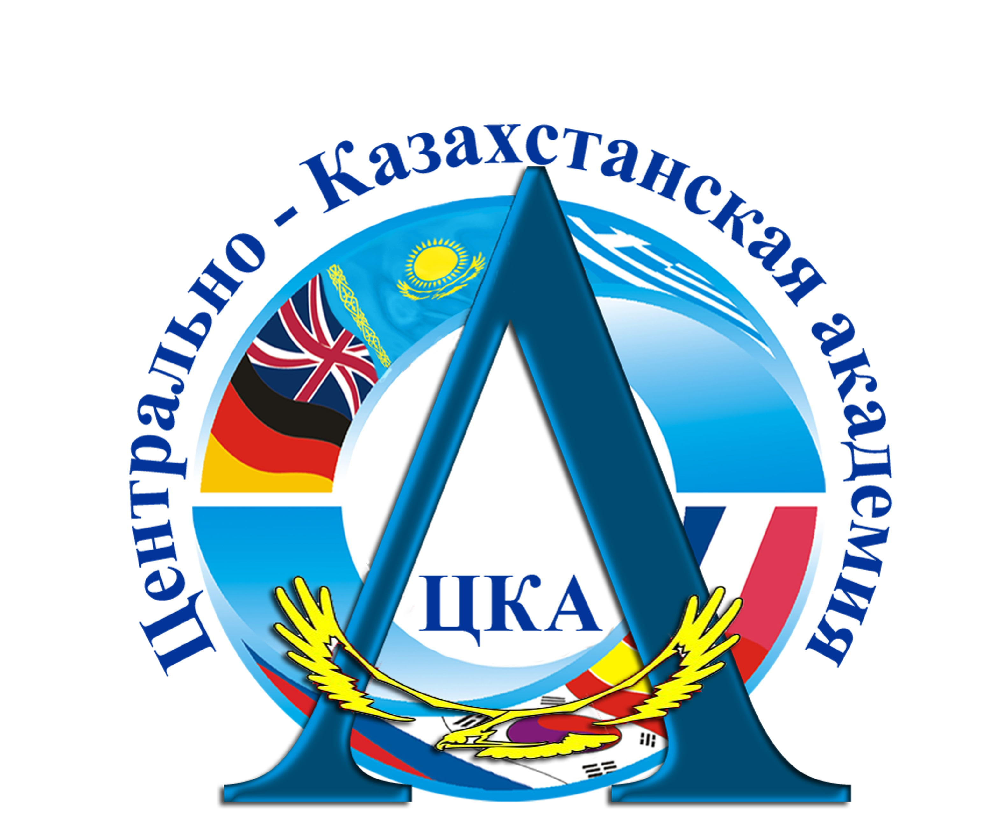

The objectives of Central - Kazakhstan Academy in the field of quality

The global objective: training of highly professional specialists of the new formation with the innovative and creative type of thinking in accordance with interests and requirements of an individual, the society and state.
1. Improvement of quality of educational activity on the basis of implementation of the requirements of the state standards, introduction of advanced teaching technologies, and as a result, increasing of the competitiveness of the university in the market of educational services in Central - Kazakhstan and expanding the possibility to obtain government contracts.
2. Continuous improvement of the processes of the university’ activity having the effect on the quality of education that leads to increasing of satisfaction of all consumers of educational services.
3. Creation and implementation of the effective management system that provides the clear delineation of the powers and responsibilities of the personnel, development of effective mechanisms for the employees’ moral and material motivation, and the provision of the personnel with the necessary resources.
4. Improvement of the material and technical basis of Academy.
5. Integration of the educational and scientific activity, involvement of Faculty members and students into the scientific activity.
6. Creation of conditions for professional development and creative potential of the Faculty members and teaching and support staff.
7. Creation of motivation mechanisms for the Academy personnel, increasing the responsibility of the HEI staff for the quality of education and greater satisfaction with their work.
8. Development of the marketing researches of the labor market, supply and demand for educational services in the field of economics and finance, law, management, social sphere, pedagogy, information systems.
9. Improvement of the culture, infrastructure and production environment of the HEI.

Rector B.Zh. Zhunusov

Appendix №2 to the order from Apr., 4, 2015 case record № 13

Release 1 copy № __________

The policy of Central-Kazakhstan academy in the field of quality

Central - Kazakhstan academy provides training of specialists in programs of higher and postgraduate education, in areas to be in priority for Central Kazakhstan.
The activity of CKA is aimed at providing of high-quality educational services in accordance with the state standards and regulatory requirements, taking into account the staffing requirements in specialists with the innovative and creative type of thinking.
The Academy strives for continuous improvement of efficiency of its functioning by implementing the provisions of the national model of higher education, taking into account the modern world trends.
The senior staff of Academy commits itself to provide dynamic development of the university as an educational and scientific complex based on the principles of initiative and responsibility, searching of ways to improve the system, providing the required resources and creating the conditions for the professional growth and social protection of employees.
Based on the principle of leadership, the senior staff of the university guarantees the implementation of the objectives to be set on the basis of the regular analysis of the reliable data.

Rector B.Zh. Zhunusov

Appendix №1 to the order from Apr., 4, 2015 case record № 13

Release 1 copy № __________

